
A 10
Sreenidhi Institute of Science & Technology
(An Autonomous Institution)
Code No: 101MA03/111MA03
B. TECH. I – Year II – Semester Examinations, July, 2013 (Supplementary)
ENGINEERING MATHEMATICS - II (Common to all branches except BT)

Time: 3 Hours Max. Marks : 70

Note : No additional answer sheets will be provided.

Part-A (Objective Type)
Max.Marks:20

Answer all QUESTIONS.

1. The differential equation satisfied by y=C₁e^{x}+ C₂e^{-x} is _________.

2. The general solution of 2xy²dx+ye^{x}dx-e^{x}dy=0 is _______.

3. State Newton’s Laws of cooling.

4. A particular solution of (D²+9) y = cos 3x is _________.

5. 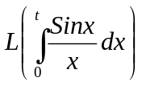 is __________.
6. If z(u_{n}) = u(z), then z (a^{-n} u_{n})=__________.

7. A vector 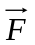 is said to be solenoidal if ____ and irrotational if _________.

8. If is the position vector, then div=________.

9. If f(x) = |x| on (-1,1), then the Fourier coefficient a₀ is given by ______.

10. If M(x,y) and N(x,y) are continuous functions over a region R bounded closed curve C, then 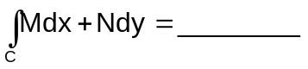.
Part – B
Max. Marks: 50

ANSWER ANY FIVE QUESTIONS. EACH QUESTION CARRIES 10 MARKS.
1. a) Solve 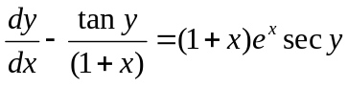. [ 5 ]
b) Find the orthogonal trajectories of the family of cardioids r=a(1-cosθ), where “a” is a parameter. [ 5 ]
2. a) Solve 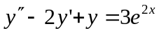. [ 5 ]

b) By using variation of parameters solve y"+4y=tan2x. [ 5 ]

3. Find the Laplace transform of the 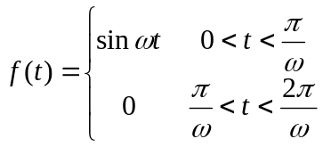 with period T=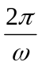.
4. Verify gauss divergence theorem for 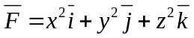 over the cuboid bounded by the planes x=0, x=a, y=0, y=b, z=0, z=c.
5. a) Find z(u _{n+2}) if z(u_{n}) = 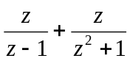. [ 5 ]

b) Solve by using Z-transform, the difference equation u_{n}+2+2u_{n+1}+u_{n}=n with u₀=u₁=0. [ 5 ]

6. Find the Fourier series of the function f(x)=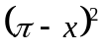 in 0<x<2π and show that 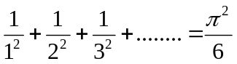.
7. a) Find the half range cosine series of [ 5 ]
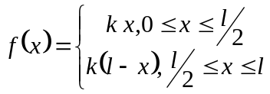.
b) Find L(te^{3t}sin 2t). [ 5 ]

8. Verify Green’s theorem in the plane for 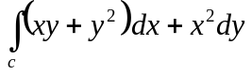where C is the closed curve of the region bounded by y=x and y=x².

-- 00 -- 00 --

